**Experiment Title – 3.3**

**Student Name:** YANA SRIVASTAVA **UID:** 20BCS2279

**Branch:** BE-CSE **Section/Group:** 20BCS-WM-906/B

**Semester:** 5th  **Subject Code:** 21 CSP-321

**Subject Name:** PBLJ LAB

**1.Aim:** Create JSP application for addition, multiplication and division.

**2. Software/Hardware Requirements:** VS Code or Eclipse

**3. Algorithm/ PsuedoCode:**

STEP 1: Create a index.jsp file in a webapp directory.

STEP 2: Create a package named as fun and create a java file named as functions.java.

STEP 3: functions.java file contains the logic for Performing the Operation such as addition, Division and Subtraction.

STEP 4: At Last start the server and display the output on the web browser.

STEP 5: EXIT.

**CODE:**

***Index.jsp***

<%@ page language=*"java"* contentType=*"text/html; charset=ISO-8859-1"*

pageEncoding=*"ISO-8859-1"*%>

<!DOCTYPE html>

<html>

<head>

<meta charset=*"ISO-8859-1"*>

<title>Calculator</title>

<style>

**body**{

background: *black*;

color: *white*;

}

**h1**{

text-align: *center*;

}

*.Paramter*{

border: *2px solid white*;background: *blue*;

padding: *5px*;

max-width: *500px*;

margin: *auto*;

font-size: *19px*;

}

**button**{

position: *relative*;

left: *170px*;

margin: *10px*; width: *60px*;height:*30px*;

cursor:*pointer*;border-radius:*5px*;

}

**button***:hover*{

background: *orange*;

}

</style>

</head>

<body>

<br/>

<div class=*"Paramter"*>

<form name=*"funcitons"* action=*"*<%=request.getContextPath()%>*/functions"* method=*"post"* >

<h1>Mathematical Operation</h1>

<input type=*"radio"* id=*"add"* name=*"fun"* value=*"+"*> Addition <br/>

<input type=*"radio"* id=*"mul"* name=*"fun"* value=*"*"*> Multiplication <br/>

<input type=*"radio"* id=*"sub"* name=*"fun"* value=*"-"*> Subtraction <br/><br/>

Enter the First Value: <input type=*"number"* name=*"fst"*><br/><br/>

Enter the Second Value: <input type=*"number"* name=*"snd"*><br/>

<button type=*"submit"*>Submit</button>

<button value=*"Reset"*>Reset</button>

</form>

<h1>Ans = <%=request.getAttribute("ans") %></h1>

</div>

</body>

</html>

***Functions.java***

package fun;

import java.io.IOException;

import javax.servlet.ServletException;

import javax.servlet.annotation.WebServlet;

import javax.servlet.http.HttpServlet;

import javax.servlet.http.HttpServletRequest;

import javax.servlet.http.HttpServletResponse;

/**

* Servlet implementation class functions

*/

@WebServlet(name="functions",urlPatterns={"/functions"})

public class functions extends HttpServlet {

protected void doPost(HttpServletRequest request, HttpServletResponse response) throws ServletException, IOException {

String a=request.getParameter("fst");

String b=request.getParameter("snd");

String fun=request.getParameter("fun");

try {

System.out.println(a+fun+b);

int i1=Integer.parseInt(a);

int i2=Integer.parseInt(b);

int ans=0;

if(fun.equals("+")) {

ans=i1+i2;

}else if(fun.equals("-")) {

ans=i1-i2;

}else if(fun.equals("*")) {

ans=i1*i2;

}

// System.out.println(ans);

request.setAttribute("ans", ans);

request.getRequestDispatcher("index.jsp").forward(request,response);

}catch(Exception e) {

System.out.println(e);

}

}

}

**OUTPUT:**

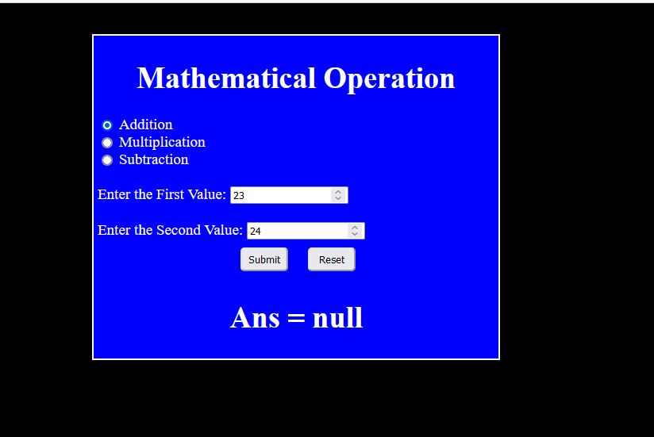

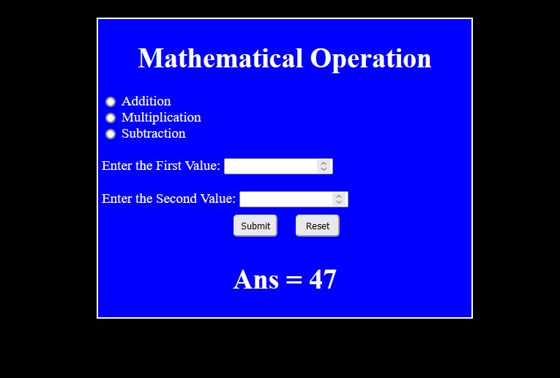

**Learning outcomes (What I have learnt):**

1. Learn About the servlet.
2. Learn about jsp and dynamic web project.
3. Learn about the tomcat server and its integrations with the java.